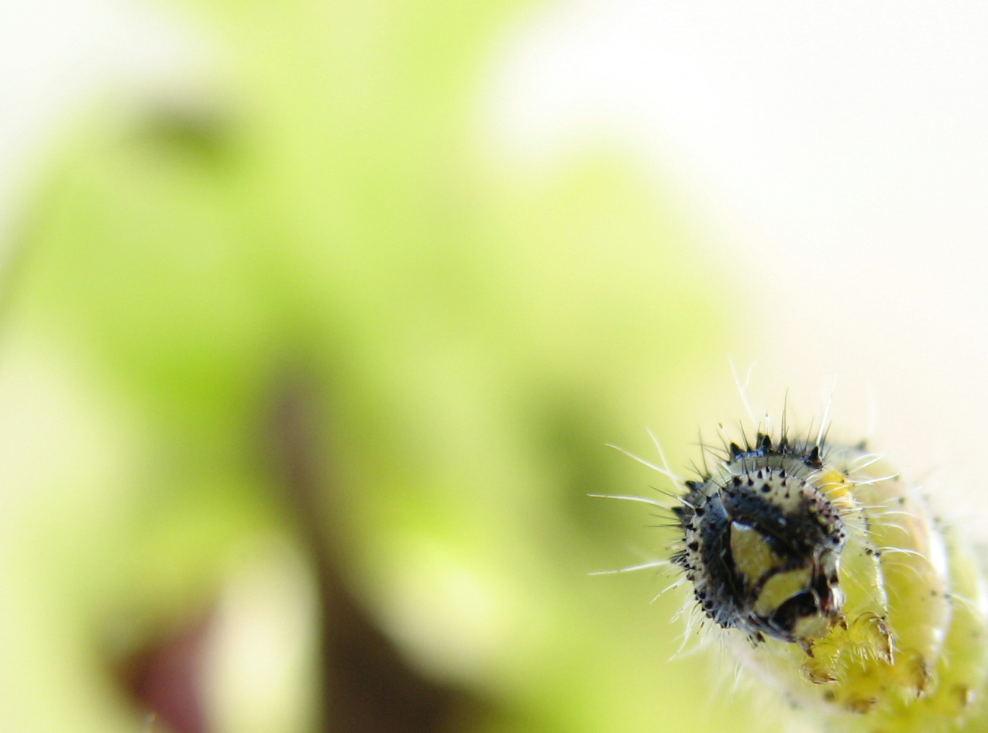

Index

Index 2
Introduction 3
Aims 4
Aim 4
Sub-Aims 4
Hypothesis 4
Theory 5
The Large Cabbage White 5
Environment 6
Enzymes 6
The arrangment of the Large Cabbage White in the animal kingdom 6
Experimental Section 7
List of Materials 7
Materials needed for developing the Large Cabbage White 7
Materials needed for the ‘Vlinderbak’ 7
Method 7
Experiment with caterpillars of Large Cabbage White 7
Experiment with butterflies of Large Cabbage White 8
Making fake flowers 8
Results 9
Dates 9
Graph 10
Weights and lengths 11
Conclusion 14
Discussion 16
Bibliography 17
Books 17
Sites 17
Logbook 19
Appendix 1 23
Appendix 2 33

Introduction

Imagine being outside in the summer an seeing all kinds of butterflies flying around. It’s a beautiful sight and you wonder, how do they live and grow?
Well, we did the wondering for you. We asked ourselves these questions and set out to find the answers.
In this paper you will find two experiments to answer these questions. The first is about the development of the eggs of the Large Cabbage White. Which circumstances are best for them, do they grow better when it’s warm and which food makes them grow biggest. With this they need light of course, as long as in summer, at least 16 hours a day, so that we also gave them. We measured and weighed the caterpillars and pupas. We also measured how long it took the eggs to become a pupa.
The next experiment is with butterflies. Butterflies eat different foods then caterpillars, they need sugar. So in an behavioural experiment we tested which food they like best, we chose honey, pure sugar and banana.
Curious? Read on to find out our results and how you can do it yourself!

Aims

Aim

Which living conditions are best for the development of the Large Cabbage White and which food do they like best?

Sub-Aims

What is the influence of different temperatures and foods on the development of the Large Cabbage White?
Which food does the Large Cabbage White like best?

Hypothesis

The Large Cabbage White develops fastest in a temperature of around 20 ºC because this is found in our literature
The Large Cabbage White develops fastest when it has Kale (Boerenkool) to eat, because that is implicated in our literature
Favourite food of the Large Cabbage White is the mix of sugar and water, because they need sugar and therefore pure sugar is the most nutritious for them.

Theory

The Large Cabbage White

The Large Cabbage White (Pieris Brassicae) is one of the most common butterflies living in the Netherlands. Its eggs are laid in groups of around 60 on the underside of cruciferae leaves (kruisbloemigen). Cabbage plants are a part of this family. The host-plants for their eggs are recognized by the sensilla (gevoelige cellen) which female butterflies have at the end of the antenna and paws. When the eggs are laid, they stick to the plant like glue, this gives protection from the sun and prevents them from being washed off when it is raining.
The yellow eggs have ridges from the top to the underside. The eggs become more yellow during their development. The eggs hatch out after four days. The little caterpillars make a hole which is as big as their head with their jaws. First the head comes out, then the front legs, the hind legs are pulled out by its front legs. The caterpillar wriggles with its body to leave the egg as soon as possible, this minimizes the chance of getting eaten by its enemies.
When the caterpillar is out of the egg, the eggs shape is preserved by the ridges on it. The caterpillars first eat their egg, it contains some vital nutrients for them, then they start eating the host-plant. This is why the butterflies make sure they choose the right host-plant, the caterpillars eats only one kind of food, so if the wrong host-plant is chosen the caterpillars will not eat and then die quickly. The host-plants for Large Cabbage Whites are most kinds of Cabbage plants.

Caterpillars can’t breathe as humans do, their skin does not let oxygen through and they don’t have lungs. Caterpillars breathe through holes in the side of their body. These are called spiracles. Through the spiracles, oxygen goes through small tubes called trachea and is then absorbed by body liquids.
A caterpillar receives information about the environment by using two sensing organs, their antenna and their primitive light-sensitive eyes. The caterpillars body consists of segments and legs, it also contains a huge amount of muscle. The caterpillar moves by contracting these muscles in the rear segments, this pushes the blood to the front segments, it then elongates the torso forwards and start again for the next move.
Caterpillars have many ways to protect themselves from their enemies. Below are named a few of these methods:
- Having a body with bright colours.
- Camouflaging itself (having a camouflaging colour, looking like for instance a bird dropping, or something that belongs in the surrounding environment.)
- Being poisonous by eating poisonous plant
- Spreading a discouraging smell
Before caterpillars can turn into a pupa they have to grow. In order to fit into their skin but keep growing at the same time their skin peels off several times before changing into a pupa.
In seventeen days the caterpillars eat very much and grow thick and long, after which they start pupating. Pupating is changing into a pupa. Pupating happens under influence of hormones.
When talking about butterflies (dagvlinders) the stage before becoming a butterfly is called a pupa. When talking about moths (nachtvlinders) the name is cocoon.

Before a caterpillar starts pupating it searches for a suitable place. This differs from specie to specie. Some species do not need a safe space because of their dangerous appearance. The Large Cabbage White does not have a dangerous appearance, thus it needs a safe place to pupate. When a safe place is found the caterpillar climbs on a branch and turns upside down. Grabs the surface with its claws and fastens itself to the branch with silk fibres. These fibres are produced by the caterpillars abdominal gland (spinklier) and are spun around the caterpillars body after the caterpillar has attached itself to the branch, it has then turned around again. The pupating takes one or two days. The skin of the pupa is already present under the skin of the caterpillar. When the caterpillar starts twisting its body, the skin is easily ripped open. Slowly the old skin comes off entirely. The new skin is week at first, but dries out fast. The silk fibre around the body is maintained for safety. The caterpillar remains in place by claspers (staarthaken) which it fastens into its ‘spinsel’.
Being a pupa is the only possible way for The Large Cabbage White to live through winter.
The pupa of the Cabbage White changes colour over time. In the beginning it has a green colour, a few days before the pupa hatches out the colour has changed to light brown. The wings will be visible too.

After about eleven days the pupa hatches out, which only takes a few minutes. Sometimes the pupa moves to and fro, this increases a few days before it hatches out. The back of the pupa rips open and the butterfly starts to wriggle itself out. When it has hatched out its wings are still wet and folded up. Blood is pumped into the wings to pump them up. When the final shape of the wings has been reached the wings dry out, this causes the wings to loose their elasticity and stay in shape. The pumping of the wings does not take long and after it is done all the blood is pumped back out of the wings into the body of the butterfly. This makes the wings strong and light.
A butterfly can see colours and detect movements very well. It has eyes which are composed of a large number of smaller eyes.
The most important food for a butterfly is nectar gotten from flowers, but some butterflies also eat the juice of rotten fruit, dead animals, manure or urine.
The Cabbage White becomes sexually mature after 3 to 4 days after it has hatched out. It will start looking for a mating partner. The butterflies can live up to two weeks.
The male and female Cabbage Whites have a difference in appearance. The wings of the male are totally white on the inside, the wings of the female have two spots on the inside of each wing.

Environment

The Large Cabbage White is a butterfly that migrates from the European mainland to England. Sometimes they fly in swarms. A Large Cabbage White first need to exist are Cabbage. It can’t live higher then 2600 meters above sea level. They live almost everywhere on the world up until 66°NB.
They fly from March until October, in general there are two generations of Large Cabbage Whites a year, in the Netherlands sometimes three.
The Large Cabbage White lives in open areas. In theory it develops best in a climate which is not too dry (humidity around at least 60%) and has a temperature of around 20 degrees. It also needs light to develop, they need at least around 16 hours of light. This is about the same number of hours of light on a summer day.

Enzymes

Butterflies are cold-blooded animals. Beneath fifteen degrees they are not active. The activity of the butterflies enzymes are determined by the amount of end production that is made. It is also dependant on acid level, enzyme-substrate concentration and by spoiled foods. Enzymes are katalysators. The enzyme binds to a substrate if everything goes right. That is how the right product can be formed. At a low temperature the enzymes work slower. When the temperature (or acid level) gets too high the secondary and tertiary structure of the enzyme changes. This can’t be undone and is called denaturising. The consequence of denaturising is that the affected enzyme can’t bind the substrate anymore. This causes the lowering of even complete halt of the production of a certain product, this is how the processes of life can be stopped.

The first butterflies existed during the Jurassic period (het Jura) (62 million years ago)

The following piece will be in Dutch:

The arrangment of the Large Cabbage White in the animal kingdom

Rijk: animalia
Stam: arthropoda = geleedpotigen
Klasse: insecta
Orde: lepidoptera = Butterflies (There are only six families of butterflies)
Familie : Pieradae = Whites
Geslacht: Pieris
Soort: Pieris Brassicae = Large Cabbage White

Experimental Section

List of Materials

Materials needed for developing the Large Cabbage White:
- Eggs of Large Cabbage White
- 3 Coolers which can also heat
- 9 plastic terrariums (small, 3 have to fit in one cooler)
- 3 thermostats which can heat and cool
- Panty hoses for around the lids of the terrariums
- Scales (very precise, on 10 000 exact), calliper (schuifmaat)
- Food (Kale, Red Cabbage, Cabbage (Spitskool))
- Power Supply
- Fluorescent Lamp Tubes
- Time switch
- Lid for opening in the coolers (see through)
- Secluded room (keep temperature and humidity stable) with power socket(s)
- Display

Materials needed for the ‘Vlinderbak’:
- Large see through terrarium with door
- Fake flowers:
Blue paper, some measuring glasses, a sponge for each measuring glass, water
and sugar, honey and banana
- Food
- Branches
- Cabbage plant
- Soil (floor coverage)
- Moss
- Some kale
- Old leaves

Method

Experiment with caterpillars of Large Cabbage White:
- Collect all materials
- Make a square hole in the biggest side of the 3 coolers.
- Fit a see through lid on the square holes in the coolers (to let the light through).
- Drill a hole in the middle of these lids for the thermostats sensor to just fit through.
- Arrange the coolers on the display.
- Install the three thermostats one on 15 degrees one on 20, one on 25. Make sure the thermostats can heat and cool.
- When the room is about 20 degrees, put two coolers on cooling and one on heating.
- Attach the power supplies to the coolers.
- Put the thermostats in the power sockets and put the heating cooler in the thermostat for 25 degrees, plug the other two coolers in the thermostats for 15 and 20 degrees.
- Get all the lids off the little terrariums and put them in a pantyhose, make sure it cant get off.
- Put the terrariums in place in the coolers (three in each, see arrangement in cooler in appendix 2), shield the one in front of the ventilator inside the cooler of direct ventilation by attaching a piece of cardboard to it.
- Pull the thermostats sensors through the hole in the lid and place them just above, in the middle of the three terrariums in each cooler.
- Place the FL tubes above the coolers so that they all have light.
- Plug the Time switch in a power socket and plug the lights in the time switch.
- Set the Time switch so that there are 16 hours of light everyday.
- Place the three different foods in the three terrariums.
- Place one little leaf of butterfly eggs in each terrarium.
- Note the day the eggs were placed.
- Note the date, and how many eggs have come out that date, check each day to see if more eggs have come out
- If there are caterpillars, make sure there is enough fresh food for them, check each day
- Clean the terrariums if it is filthy, handle the caterpillars gently when getting them out, the are easy to kill.
- When the caterpillars have grown large and fat they will soon change into pupa. Measure and weigh each caterpillar that is almost going to change into a pupa.
- When they are really going to change into a pupa they attach themselves to the side of the terrarium. Write down when you see this.
- Eventually you will find pupa’s in your terrarium.
- They are attached to the sides at their tail and with to threads at each side. Cut the two threads with scissors and pry the tail gently loose.
- Weigh and measure the pupa(s).
- Keep the pupa somewhere warm and safe until you can put them in your ‘vlinderbak’

Experiment with butterflies of Large Cabbage White:
- Collect all materials.
- Cover the floor with the soil.
- Put the branches in, pick long branches which can reach to the top of the ‘vlinderbak’ the branches are for the butterflies to dry their wings and rest on.
- Make the fake flowers (see below) and put them in
- arrange moss around the fake flowers so the butterflies can climb to it (not all butterflies can fly really well)
- Put the cabbage plant in, be sure to water it.
- If you don’t want new caterpillars put the cabbage plant in the freezer for two or three hours. (only once every couple of days)
- Lay the old leaves on the ground, spread it out only a bit
- Lay the pupa’s on the leaves, with their backs up so they can’t turn on their backs when coming out
- When you have at least 10, preferably more, butterflies start the experiment
- Prepare three different kinds of fake flowers, one with sugar, one with honey and one with banana. (see below)
- Put them in.
- Watch for at least 3 hours and note how many times the butterflies ate from the different fake flowers.

Making fake flowers:
- Cut flowers out of blue paper, fit them to wrap around the measuring glasses
- Fill the glasses with 9 parts water and 1 part sugar, honey or banana..
- Fake flowers just for food: just guess how much water and honey is needed.
- Fake flowers for the experiment: Weigh the exact amount of water and sugar, honey or banana is needed. (1 part food, 9 parts water)
- Note these amounts.
- When filled, soak the sponge in the mixture.
- Make sure the butterflies can only eat on the sponge.
- Wrap the fake flowers around the measuring glass.

Results

Dates

Table 1 With dates is in appendix 1

Table 2: Comparing different terrariums:
For explanation of terrarium codes, see appendix 2
Numbers in red don’t fit

Terrarium | Duration lifecycle in days | Amount of pupa’s | Time eggs in terrarium | Time caterpillars in terrarium | Time changing to pupa in terrarium | Time pupas in terrarium | Time between first caterpillar and first pupa
R1.1 | 53 | 7 | 5 | 36 | 11 | 9 | 29  15 graden
S1.2 | 30 | 13 | 3 | 27 | 5 | 5 | 23
B1.3 | 35 | 21 | 2 | 31 | 13 | 12 | 21
R2.1 | 67 | 5 | 7 | 59 | 9 | 7 | 55  20 graden
S2.2 | 55 | 4 | 4 | 49 | 13 | 11 | 40
B2.3 | 56 | 4 | 3 | 49 | 8 | 6 | 47
R3.1 | 22 | 16 | 1 | 18 | 4 | 3 | 17  25 graden
S3.2 | 21 | 5 | 5 | 17 | 6 | 5 | 15
B3.3 | 21 | 12 | 1 | 18 | 4 | 3 | 16

When comparing duration lifecycle:
15 degrees is around 55 days, 20 degrees is around 32, 25 degrees is around 21

When comparing time of caterpillars:
15 degrees is around 49 days, 20 degrees is around 31, 25 degrees is around 18

When comparing time of pupas:
15 degrees is around 8 days, 20 degrees is around 9, 25 degrees is around 4

When comparing time it took from caterpillar to pupa:
15 degrees is around 43 days, 20 degrees is around 24, 25 degrees is around 16

This means that the type of food has no, or little influence over the duration of the Large Cabbage Whites life cycle. As is seen in the table, the times for the different foods do not differ that much. Thus we made a graph of the averages named above in green.

Graph

This graph shows the relationship between the time certain developments of the Large Cabbage White took. It shows this for the three different temperatures: 15, 20 and 25 degrees. The first shows how long it took for the different temperatures to develop from eggs to pupas, the second shows how long there were caterpillars in the different terrariums, the third shows how long there where pupas in the terrarium, and the last shows how long it took the caterpillars to all change in to pupas. All the numbers are averages of the different foods.

This graph shows us that for all the different developments the Large Cabbage Whites in a temperature of 25 degrees develops fastest, second fastest are the Large Cabbage Whites in a temp. of 20 degrees, slowest in development are the Large Cabbage Whites in a temp. of 15 degrees.
The only development for which this doesn’t count is the time there were pupas in the terrarium, why this happened is discussed in the discussion.
Weights and lengths

Table 3: Weights and lengths

Terrarium | Weight Caterpillars | Lenght Caterpillars | Weight Pupas | Length Pupa | Terrarium | Weight Caterpillars | Lenght Caterpillars | Weight Pupas | Length Pupa
B1.3 | gr 0,3613 |  | gr 0,3617 | +/- 2,05? | R3.1 | gr 0,3826 | cm 3,55 | gr 0,34 | cm 1,9
 | 0,449 |  | 0,357 x 3 |  |  | 0,3989 | 3,45 | 0,423 | 2,05 x 3
(20 graden) | 0,4534 | +/- 3,9 ? | 0,346 x 4 |  |  | 0,4108 | 3,65 | 0,35 | 1,95 x 2
 | 0,4287 |  | 0,340 x 4 |  |  | 0,3225 | 3,4 | 0,325 | 2,0 x 2
 | 0,4356 |  | 0,327 x 3 |  | (25 graden) | 0,3296 | 3,3 | 0,3155 x 6 | 2,1
 | 0,4793 |  | 0,302 x 3 |  |  |  |  | 0,316 | 1,9
 | 0,4234 |  |  |  | Average | 0,3689 | 3,47 | 0,3315 | 1,995
Average | 0,433 |  | 0,337 |  | S1.2 | gr 0,4650 | cm 3,45 | gr 0,377 | cm 2,1
B2.3 | gr 0,359 | cm 3,2 | gr 0,282 | cm 2,0 |  | 0,451 | 3,65 | 0,374 | 2,15
(15 graden) | 0,308 | 2,6 | 0,314 | 2 | (20 graden) | 0,467 | 3,8 | 0,343 | 2,2
 | 0,362 | 3,1 | 0,291 | 2 |  | 0,4615 | 3,3 | 0,333 | 2,1
 | 0,269 | 2,6 | 0,28 | 1,8 |  | 0,497 | 4 | 0,33 | 2,1
Average | 0,3245 | 2,875 | 0,2918 | 1,95 |  | 0,391 | 3,45 | 0,38 | 2,2
B3.3 | gr 0,371 | cm 3,5 | gr 0,358 | cm 1,7 |  | 0,541 | 3,9 | 0,322 | 2,1
 | 0,345 | 3,6 | 0,356 | 1,9 |  | 0,5175 | 3,6 | 0,318 | 2,1
(25 graden) | 0,352 | 3,45 | 0,36 | 1,9 |  | 0,486 | 3,7 | 0,344 | 2
 | 0,299 | 3,5 | 0,358 | 1,8 |  | 0,4689 | 3,7 | 0,361 | 2,1
 | 0,388 | 3,45 | 0,358 | 1,9 |  | 0,395 | 3,1 | 0,345 | 2,05
 |  |  | 0,308 | 1,8 |  | 0,314 | 3,05
Average | 0,351 | 3,5 | 0,3497 | 1,83 | Average | 0,4546 | 3,56 | 0,3443 | 2,11
R1.1 | gr 0,472 |  | gr 0,339 | cm 2,2 | S2.2 | gr 0,556 | cm 3,5 | gr 0,225 | cm 1,7
 | 0,5 | +/- 3,7 ? | 0,335 | 2,2 |  | 0,503 | 3,5 | 0,358 | 2,1
 | 0,46 |  | 0,334 | 2,1 | (15 graden) | 0,427 | 4 | 0,416 | 2,1
(20 graden) | 0,479 |  | 0,307 | 1,9 |  |  |  | 0,365 | 2,1
 | 0,501 |  | 0,343 | 2 | Average | 0,4953 | 3,67 | 0,341 | 2
 |  |  | 0,355 | 2,1 | S3.2 |  | 1,9  2,0  2,0 | gr 0,334 | cm 2,1
 |  |  | 0,435 | 2,2 |  |  |  | 0,381 | 2,1
Average | 0,4824 |  | 0,3497 | 2,1 | (25 graden) | +/- 0,32? |  | 0,331 | 2,05
R2.1 | gr 0,443 | cm 3,5 | gr 0,331 | cm 2,0 |  |  |  | 0,3615 | 2,1
 | 0,4034 | 3,3 | 0,335 | 2,2 |  |  |  | 0,29 | 2,15
(15 graden) |  |  | 0,274 | 1,8 | Average |  | 1,97 | 0,3395 | 2,1
 |  |  | 0,251 | 1,7
 |  |  | 0,256 | 2
Average | 0,4232 | 3,4 | 0,2894 | 1,94

gewicht rupsen
Lengte cocon
Gewicht cocon
Lengte rupsen

Tijd tussen 1ste rups en 1ste pop.
dagen
Conclusion

The First question we asked ourselves was what influence temperature and food have on the development of the Large Cabbage White. We stated that most beneficial would be an environment of around 20 degrees and giving them Kale to eat.

The 5th graph that shows the relationship between time and the different developments of the Large Cabbage White (for the three different temperatures) tells us that the Large Cabbage White develops fastest in a temperature of around 25 degrees. This is different then expected probably because the terrariums in 25 degrees where moister then in the other two temperatures, caterpillars need moist. Dit wordt veroorzaakt door de afgesloten bak en niet het geval in het natuurlijke ecosysteem. De abiotische factor ‘lucht’ is hier verstoord: omdat wind hier ontbreekt kan het vocht niet worden afgevoerd. Over het algemeen kun je concluderen dat hoe hoger de temperatuur is, des te korter is de tijd van de ontwikkeling van rups tot pop. Daarbij is te zien dat de rode kool er het langst over doet, dit is mogelijk te verklaren door het soort voedsel nl. rode kool is moeilijk te eten voor rupsen omdat de rupsen moeite hebben zich door het stugge blad te bijten. De spitskool is bij alle temperatuur het optimum. Dit wordt waarschijnlijk veroorzaakt door het zachte blad waardoor de rupsen het voedsel makkelijker tot zich kunnen nemen.

Grafiek 1 gewicht rupsen: 25 graden geeft de lichtste rupsen, een uitzondering is de boerenkool bij 15 graden. Dit kan een meetfout zijn want er waren weinig rupsen in leven gebleven.
Als je lengte en gewicht rupsen vergelijkt zie je een overeenkomst. Alleen bij de rode kool Ie je een klein verschil.
Deze overeenkomst vind je niet terug in gewicht en lengte van de cocons.

Grafiek 2 lengte van de rupsen: 20 graden geeft de langste rupsen. Behalve bij de spitskool, maar daar liggen de lengte van 15 graden en 20 graden heel dicht op elkaar. Het verschilt slechts 0,1 cm. Bij 25 graden is de spitskool opvallend klein. Qua gewicht scheelt het niet veel met de andere rupsen.

Grafiek 3 en 4 gewicht en lengte van de cocons: alle cocons zijn ongeveer even zwaar alleen de groep van de rode kool wijkt af, deze is overal (in verhouding) lichter.
Als je de grafiek van de rupsen en de cocons vergelijkt valt op dat de lichte spitskool toch zware cocons geeft.
Als je gewicht en lengte van de cocons vergelijkt dan zie je ongeveer hetzelfde patroon, maar extremer onderling verschil. De groep van de boerenkool bij 25 graden wijkt af.

Wat niet af te lezen is dat de extreme kleine lichte cocons slecht uitkwamen (gehandicapt) of helemaal niet. De extreem grote zware cocons deden er erg lang over om uit te komen. Degene met gemengd voedsel zijn na een half jaar nog niet uitgekomen. Deze zijn extreem groot en dik.

In de eerste dagen kon je zien welke rups welk voedsel at. De rode kool was paars/blauw van binnen, de rupsen waren nog doorzichtig; de boerenkool donker groen; spitskool licht groen. De rupsen waren nog 0,0000 gram en 1 mm lang. Na een paar dagen verdween het kleurverschil. De poepkleur bleef echter verschillend. De rode kool paars/zwartige (diaree) ontlasting; de spitskool geel/groene diaree en boerenkool bruingroene korrels. Als je kijkt naar de voedingsstoffen in het voedsel dan bevat de boerenkool het minste water.

De luchtvochtigheid is al die tijd constant geweest tussen de 60 en 80 op de hygrometer (mooi weer)
De temperatuur is redelijk constant van de omgeving; de bakken van het experiment weken slechts maximaal 1 graad af .

De rupsen doen bij 25 graden ongeveer 1 dag over het verpoppen zelf, bij 20 graden ongeveer 2 dagen en bij 15 graden ongeveer 3 dagen.

Het hangt van het voedsel af hoe de cocon er uit ziet. De kleur : boerenkool, bruingroen met veel donkere stippen op het vlies; spitskool, zowel donkergroene met veel stippen als lichtgroene met weinig stippen; rode kool is lichtgroen met weinig stippen. Vlak voor ze uitkomen is het geslacht vast te stellen. Aan de tekening op de vleugels is te zien of het een mannetje of vrouwtje wordt.

Vlak voor uitkomen was het gewicht cocons 0,27 gram bij de groep rode kool (gemiddelde van 2 meetgegevens). Na uitkomen weegt de vlinder 0,15 gram (gemiddelde van 5 meetgegevens).
De oudste vlinder is bijna 5 weken geworden.

In het aquarium zaten de mannetjes en de vrouwtjes gescheiden door een glasplaat. Ze zaten het liefst tegen de plaat en bij de paarse UV-lamp waren ze actiever.

In totaal zijn er 32 mannetjes en 36 vrouwtjes uitgekomen.

The next question was what food does the Large Cabbage White like best? We thought this would be a mix of sugar and water.

The experiment to find out which food was the favourite didn’t go as planned. We sat in front of the ‘vlinderbak’ watching but nothing happened. After an hour only one butterfly had landed on a fake flower to eat. This experiment had failed.
Discussion

Bij 15 graden gingen veel kleine rupsen dood, als ze eenmaal een bepaalde grootte hadden overleefden ze wel. In de toekomst is het niet handig om bij 15 graden rupsen te kweken.
Bij een vervolgexperiment zouden we geen rode kool meer nemen, omdat de ontwikkeling minder snel gaat.

We also see that our hypothesis was wrong for what we found. The hypothesis assumed that 20 degrees would be fastest in developing, we found 25 degrees. The most probable cause for this was that is was winter at the time. We had heaters and light to fake summer, but the humidity we couldn’t fake. In winter it is drier that in summer, humidity in the terrariums in 25 degrees were probably highest due to higher evaporation from the food and the caterpillars itself, higher temperatures give more moist. This means that the low winter humidity was too low for the butterflies so that instead of the normal 20 degrees they needed 25 degrees for the higher humidity.

Bibliography

Books

- The complete encyclopaedia of butterflies, by Wijbren Landman
- Vlinders, by Paul Whalley, published 1989, Hema bv. Amsterdam

Sites

- www.soortenbank.nl
- http://en.wikipedia.org/wiki/Butterfly
- http://en.wikipedia.org/wiki/Pupa
- http://en.wikipedia.org/wiki/Caterpillar
- http://www.vlinderstichting.nl/index.asp?CatID=17&SubCatID=155&PageID=253
- http://www.hetdierenrijk.nl/World%60sNature/insecten/koolwitje.htm

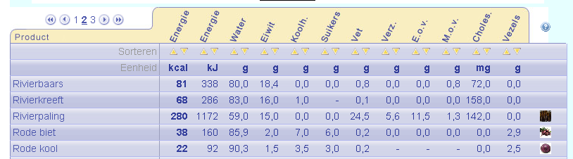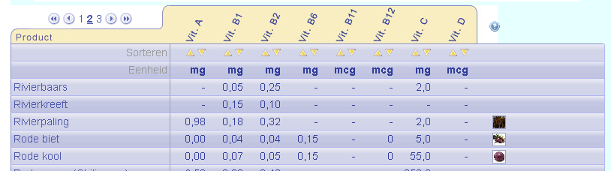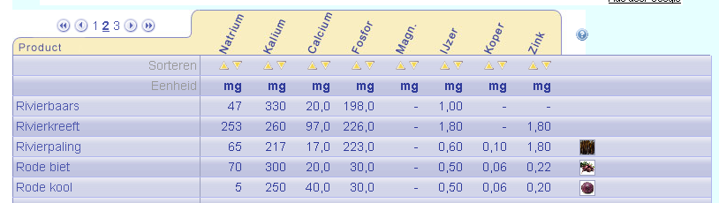
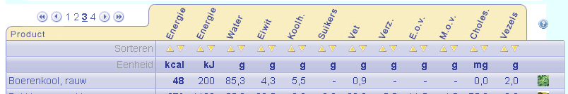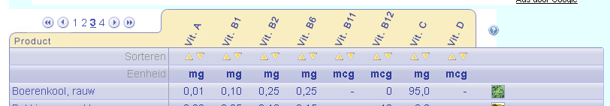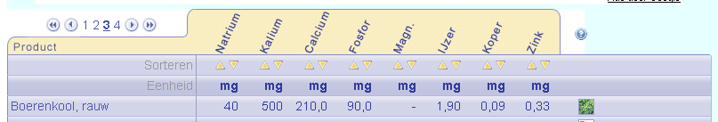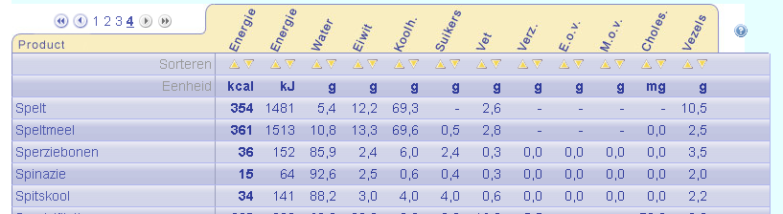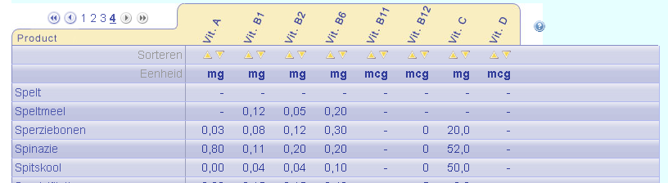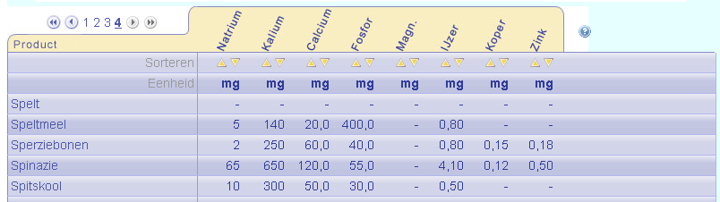

Logbook

Person | Date | Time | Activities
Willemijn, José | 10-07-07 | 5 hours | Preparation at school
José | 12-07-07 | 15 min | Copying worksheets
José | 15-07-07 | 30 min | Start theory lifecycle Cabbage White
José | 18-08-07 | 1 hour | Theory lifecycle
José | 19-08-07 | 1 hour | Read book on butterflies and making notes
José | 21-08-07 | 1 hour | Process notes and translate in English
José | 22-08-07 | 1 hour 30 min | Translating
José | 23-08-07 | 30 min | Typing out translated version
José | 24-08-07 | 1 hour 30 min | Translating
José | 25-08-07 | 30 min | Typing out
W+J | 05-09-07 | 2 hours | Discuss work plan with Nico and Mr. Went
J | 07-09-07 | 30 min | Order eggs
W+J | 12-09-07 | 30 min | Discussing work plan
W+J | 18-09-07 | 2 hours 15 min | Setting up the experiment
W+J | 19-09-07 | 2 hours 30 min | Setting up
W+J | 20-09-07 | 4 hours 15 min | Finish setting up and testing the set up
J | 20-09-07 | 30 min | Collect eggs and buy cabbage
W+J | 21-09-07 | 30 min | Appointment for weekend with Nico
J | 22-09-07 | 1 hour 30 min | Cleaning, checking and counting caterpillars
J | 23-09-07 | 1 hour 45 min | Food in terrariums, measure caterpillars, 1 mm long, photograph and film
J | 24-09-07 | 1 hour 40 min | photograph, count caterpillars, feed and clean
W | 24-09-07 | 1 hour 30 min | photograph, count caterpillars, feed and clean
W | 25-09-07 | 45 min | Clean and feed, check eggs
J | 25-09-07 | 1 hours 45 min | Photograph, process photos
J | 26-09-07 | 1 hour 30 min | Clean, count caterpillars
J | 27-09-07 | 1 hour 30 min | Clean terrariums and count caterpillars, feeding. Bought new Kale. Contact the Vlinderstichting ordering new eggs
J+W | 27-09-07 | 45 min | Dispose dead caterpillars, discuss with Mr. Went about how to go on.
W | 28-09-07 | 1 hour | Clean terrariums and feeding.
J | 28-09-07 | 20 min | Make appointments, help cleaning
J | 29-09-07 | 5 hours | Bought red cabbage and regular cabbage in natuurwinkel Zutphen. Kale from own garden, washed. Put little caterpillars on unsprayed cabbage
W | 29-09-07 | 1 hour 30 min | Helped with above
J | 30–09-07 | 1 hour 20 min | Caterpillars on new leave, feed
J+W | 1-10-07 | 20 min | New food
J | 1-10-07 | 30 min | Get kale, back to school wash for W. Fresh leave in terrarium
W | 2-10-07 | 15 min | Feeding
J | 3-10-07 | 55 min | Cleaned terrariums, fresh food, put new eggs in terrarium and counted them
J | 4-10-07 | 35 min | Feeding
W | 5-10-07 | 45min | Feeding
J | 6-10-07 | 2 hours 30 min | Cleaning, fresh food, weigh and measure
J | 7-10-07 | 1 hour 30 min | Cleaning, fresh food
J+W | 8-10-07 | 30 min | Fresh food
W | 9-10-07 | 1 hour | Fresh food, cleaning
W | 10-10-07 | 2 hours 45 min | Cleaning, feeding measure, remove pupa. Write part of report
J | 10-10-07 | 2 hours 30 min | Buy food, remove pupa, fresh food, adjust thermometer, measure
J | 11-10-07 | 3 hours | Remove pupa, photograph, clean and feed
J | 13-10-07 | 1 hour 45 min | Clean, measure, weigh
W | 14-10-07 | 1 hour 30 min | Clean and feed
W | 15-10-07 | 45 min | Clean and feed
W | 17-10-07 | 1 hour 15 min | Fresh food
J | 17-10-07 | 30 min | Measure, weigh, remove pupa
W | 18 | 1 hour 30 min | Clean, feed
W | 19 | 1 hour 30 min | Clean and feed
W | 21 | 1 hour | Clean and feed
W | 22 | 1 hour | Clean and feed
J | 23 | 30 min | Buy cabbage
J | 24-10-07 | 2 hours | Clean, feed, weigh, measure, remove pupa
J | 26-10-07 | 2 hours 10 min | photographed, bought cabbage, clean, feed, weigh, measure
J | 28-10-07 | 1 hour 30 min | Clean, remove pupa, feed, photograph
J+W | 29-10-07 | 30 min | Cleaning, fresh food, remove pupa
W | 30-10-07 | 30 min | Clean, feed
J | 31-10-07 | 1 hour 15 min | Weigh, measure, clean, feed
W | 1-11-07 | 30 min | Clean, feed
W | 2-11-07 | 30 min | Clean, feed
J | 4-11-07 | 3 hours 30 min | Clean, feed, catch escaped butterfly, set up aquarium, made food
J+W | 5-11-07 | 30 min | Clean, feed, weigh, measure
W | 6-11-07 | 15 min | Feed
J | 7-11-07 | 45 min | Photograph, process photo’s
W | 7-11-07 | 30 min | Feed, Clean
J | 8-11-07 | 20 min | Feed, weigh, measure
W | 8-11-07 | 30 min | Feed, weigh, measure
W | 11-11-07 | 30 min | Feed, clean
W | 12-11-07 | 30 min | Feed, clean, measure, weigh
W | 14-11-07 | 30 min | Feed, clean
W | 16-11-07 | 15 min | Feed, clean, measure, weigh
W | 18-11-07 | 30 min | Feed, clean
J | 19-11-07 | 45 min | Clean aquarium, feed butterflies and caterpillars
W | 20-11-07 | 30 min | Feed, clean
W | 21-11-07 | 45 min | Feed, clean, measure, weigh
W | 22-11-07 | 1 hour 45 min | Search for information on internet. Set up vlinderbak
J | 22-11-07 | 45 min | Help set up vlinderbak
W | 23-11-07 | 45 min | Feed, clean, write part of PWS report
J | 25-11-07 | 50 min | Fresh food. Made and processed photos of e.g. the set up
W | 26-22-07 | 15 min | Feed
W | 27-22-07 | 30 min | Measure, weigh
W | 29-22-07 | 10 min | Check on caterpillars
J | 30-11-07 | 1 hour 10 min | Label and process dead butterflies
J | 1-12-07 | 45 min | Type logbook and made fake flowers
W | 3-12-07 | 15 min | Fresh fake flower
W | 4-12-07 | 1 hour | Work on report
W | 5-12-07 | 2 hours | Report and made three different kinds of fake flower
W | 6-12-07 | 1 hour | Observe butterflies
W | 17-12-07 | 30 min | PWS writing
W | 18-12-07 | 4 hours 10 min | PWS writing
W | 19-12-07 | 4 hours 5 min | PWS at school, writing
W | 19-12-07 | 4 hours 15 min | PWS writing
W | 20-12-07 | 1 hour 40 min | PWS at school
J | 20-12-07 | 2 hours | Checking PWS
W | 20-12-07 | 6 hours | Finishing and correcting PWS
J | 4-02-08 | 2 hours 10 min | Enzymwerking toevoegen
J | 18-03-08 | 3 hours 45 min | Powerpoint
J | 28-06-08 | 3 hours 30 min | Profielwerkstuk afmaken

Appendix 1

Many caterpillars died when young, they are very vulnerable then. That is why we can’t know how many caterpillars survived in the early stage, and why as soon as they start changing into pupa’s we didn’t write the number of caterpillars down anymore.

Day | Date | Terrarium | Eggs | Catterpillars | Changing into pupa's | Pupa's | Comments
1 | 22-sep | R1.1 | 42 | 0 | 0 | 0
 |  | R2.1 | 36 | 0 | 0 | 0
 |  | R3.1 | 36 | 0 | 0 | 0
 |  | B1.3 | 34 | 0 | 0 | 0
 |  | B2.3 | 52 | 0 | 0 | 0
 |  | B3.3 | 51 | 0 | 0 | 0
2 | 23-sep | R1.1 | 42 | 0 | 0 | 0
 |  | R2.1 | 36 | 0 | 0 | 0
 |  | R3.1 | x | 36 | 0 | 0
 |  | B1.3 | 1 | 33 | 0 | 0
 |  | B2.3 | 52 | 0 | 0 | 0
 |  | B3.3 | x | 51 | 0 | 0
3 | 24-sep | R1.1 | 11 | 31 | 0 | 0
 |  | R2.1 | 36 | 0 | 0 | 0
 |  | R3.1 | x | 36 | 0 | 0
 |  | B1.3 | x | 34 | 0 | 0
 |  | B2.3 | 52 | 0 | 0 | 0
 |  | B3.3 | x | 51 | 0 | 0
4 | 25-sep | R1.1 | 11 | 31 | 0 | 0 | All eggs dead
 |  | R2.1 | 36 | 0 | 0 | 0
 |  | R3.1 | x | 36 | 0 | 0
 |  | B1.3 | x | 34 | 0 | 0
 |  | B2.3 | 52 | 0 | 0 | 0
 |  | B3.3 | x | 51 | 0 | 0
5 | 26-sep | R1.1 | x | 31 | 0 | 0
 |  | R2.1 | 2 | 34 | 0 | 0
 |  | R3.1 | x | 36 | 0 | 0
 |  | B1.3 | x | 34 | 0 | 0
 |  | B2.3 | 9 | 43 | 0 | 0
 |  | B3.3 | x | 51 | 0 | 0
6 | 27-sep | R1.1 | x | 31 | 0 | 0
 |  | R2.1 | 2 | 34 | 0 | 0
 |  | R3.1 | x | 36 | 0 | 0
 |  | B1.3 | x | 34 | 0 | 0
 |  | B2.3 | 9 | 43 | 0 | 0
 |  | B3.3 | x | 51 | 0 | 0
7 | 28-sep | R1.1 | x | 31 | 0 | 0
 |  | R2.1 | x | 36 | 0 | 0
 |  | R3.1 | x | 36 | 0 | 0
 |  | B1.3 | x | 34 | 0 | 0
 |  | B2.3 | 1 | 51 | 0 | 0
 |  | B3.3 | x | 51 | 0 | 0
8 | 29-sep | x | x | x | x | x | Everything in B2.3 + R1.1 is dead, ordering 5 new packages of eggs
10 | 1-okt | x | x | x | x | x | No Changes
11 | 2-okt | x | x | x | x | x | No Changes
12 | 3-okt | R1.1 | 26 | 0 | 0 | 0 | Start of S1.2, S2.2, S3.2, B2.3 and R1.1
 |  | R2.1 | x | 36 | 0 | 0 | Start of S1.2, S2.2, S3.2, B2.3 and R1.1
 |  | R3.1 | x | 36 | 0 | 0 | Start of S1.2, S2.2, S3.2, B2.3 and R1.1
 |  | S1.2 | 22 | 0 | 0 | 0
 |  | S2.2 | 16 | 0 | 0 | 0
 |  | S3.2 | 26 | 0 | 0 | 0
 |  | B1.3 | x | 34 | 0 | 0
 |  | B2.3 | 17 | 0 | 0 | 0
 |  | B3.3 | x | 51 | 0 | 0
13 | 4-okt | R1.1 | 26 | 0 | 0 | 0
 |  | R2.1 | x | 36 | 0 | 0
 |  | R3.1 | x | 36 | 0 | 0
 |  | S1.2 | 22 | 0 | 0 | 0
 |  | S2.2 | 16 | 0 | 0 | 0
 |  | S3.2 | 25 | 1 | 0 | 0
 |  | B1.3 | x | 34 | 0 | 0
 |  | B2.3 | 17 | 0 | 0 | 0
 |  | B3.3 | x | 51 | 0 | 0
14 | 5-okt | R1.1 | 26 | 0 | 0 | 0
 |  | R2.1 | x | 36 | 0 | 0
 |  | R3.1 | x | 36 | 0 | 0
 |  | S1.2 | 10 | 12 | 0 | 0
 |  | S2.2 | 16 | 0 | 0 | 0
 |  | S3.2 | 18 | 7 | 0 | 0
 |  | B1.3 | x | 34 | 0 | 0
 |  | B2.3 | 17 | 0 | 0 | 0
 |  | B3.3 | x | 51 | 0 | 0
15 | 6-okt | R1.1 | 9 | 17 | 0 | 0
 |  | R2.1 | x | 36 | 0 | 0
 |  | R3.1 | x | 36 | 0 | 0
 |  | S1.2 | x | 22 | 0 | 0
 |  | S2.2 | 16 | 0 | 0 | 0
 |  | S3.2 | 17 | 8 | 0 | 0
 |  | B1.3 | x | 34 | 0 | 0
 |  | B2.3 | x | 17 | 0 | 0
 |  | B3.3 | x | 51 | 0 | 0
16 | 7-okt | R1.1 | 1 | 25 | 0 | 0
 |  | R2.1 | x | 36 | 0 | 0
 |  | R3.1 | x | 36 | 0 | 0
 |  | S1.2 | x | 22 | 0 | 0
 |  | S2.2 | x | 16 | 0 | 0
 |  | S3.2 | 17 | 8 | 0 | 0 | probably eggs are dead
 |  | B1.3 | x | 34 | 0 | 0
 |  | B2.3 | x | 17 | 0 | 0
 |  | B3.3 | x | 51 | 0 | 0
17 | 8-okt | R1.1 | x | 26 | 0 | 0
 |  | R2.1 | x | 36 | 0 | 0
 |  | R3.1 | x | 36 | 0 | 0
 |  | S1.2 | x | 22 | 0 | 0
 |  | S2.2 | x | 16 | 0 | 0
 |  | S3.2 | x | 8 | 0 | 0
 |  | B1.3 | x | 34 | 0 | 0
 |  | B2.3 | x | 17 | 0 | 0
 |  | B3.3 | x | x | 2 | 0
18 | 9-okt | R1.1 | x | 31 | 0 | 0
 |  | R2.1 | x | 36 | 0 | 0
 |  | R3.1 | x | x | 6 | 0
 |  | S1.2 | x | 22 | 0 | 0
 |  | S2.2 | x | 16 | 0 | 0
 |  | S3.2 | x | 8 | 0 | 0
 |  | B1.3 | x | 34 | 0 | 0
 |  | B2.3 | x | 17 | 0 | 0
 |  | B3.3 | x | x | 2 | 1 | 2 pupa, 1 dead
19 | 10-okt | R1.1 | x | 31 | 0 | 0
 |  | R2.1 | x | 36 | 0 | 0
 |  | R3.1 | x | x | 8 | 6 | 2 dead
 |  | S1.2 | x | 22 | 0 | 0
 |  | S2.2 | x | 16 | 0 | 0
 |  | S3.2 | x | 8 | 0 | 0
 |  | B1.3 | x | 34 | 0 | 0
 |  | B2.3 | x | 17 | 0 | 0
 |  | B3.3 | x | x | 8 | 5
20 | 11-okt | R1.1 | x | 31 | 0 | 0
 |  | R2.1 | x | 36 | 0 | 0
 |  | R3.1 | x | x | 4 | 12 | 2 dead
 |  | S1.2 | x | 22 | 0 | 0
 |  | S2.2 | x | 16 | 0 | 0
 |  | S3.2 | x | 5 | 0 | 0 | Only five caterpillars survived
 |  | B1.3 | x | 34 | 0 | 0
 |  | B2.3 | x | 17 | 0 | 0
 |  | B3.3 | x | 2 | 1 | 11 | 1 dead, one half-dead
21 | 12-okt | R1.1 | x | 31 | 0 | 0
 |  | R2.1 | x | 36 | 0 | 0
 |  | R3.1 | x | x | 1 | 15
 |  | S1.2 | x | 22 | 0 | 0
 |  | S2.2 | x | 16 | 0 | 0
 |  | S3.2 | x | 5 | 0 | 0
 |  | B1.3 | x | 34 | 0 | 0
 |  | B2.3 | x | 17 | 0 | 0
 |  | B3.3 | x | 1 | 0 | 12 | Last pupa of B3.3
22 | 13-okt | R1.1 | x | 31 | 0 | 0
 |  | R2.1 | x | 36 | 0 | 0
 |  | R3.1 | x | x | x | x
 |  | S1.2 | x | 22 | 0 | 0
 |  | S2.2 | x | 16 | 0 | 0
 |  | S3.2 | x | 5 | 0 | 0
 |  | B1.3 | x | x | 4 | 0
 |  | B2.3 | x | 17 | 0 | 0
 |  | B3.3 | x | 1 | 0 | 12
23 | 14-okt | R1.1 | x | 31 | 0 | 0
 |  | R2.1 | x | 36 | 0 | 0
 |  | R3.1 | x | x | x | x
 |  | S1.2 | x | 22 | 0 | 0
 |  | S2.2 | x | 16 | 0 | 0
 |  | S3.2 | x | 5 | 0 | 0
 |  | B1.3 | x | x | 15 | 2
 |  | B2.3 | x | 17 | 0 | 0
 |  | B3.3 | x | 1 | 0 | 12
24 | 15-okt | R1.1 | x | 31 | 0 | 0
 |  | R2.1 | x | 36 | 0 | 0
 |  | R3.1 | x | x | x | x
 |  | S1.2 | x | 22 | 0 | 0
 |  | S2.2 | x | 16 | 0 | 0
 |  | S3.2 | x | 5 | 0 | 0
 |  | B1.3 | x | x | 8 | 9
 |  | B2.3 | x | 17 | 0 | 0
 |  | B3.3 | x | x | x | x | Last caterpillar dead
26 | 17-okt | R1.1 | x | 31 | 0 | 0
 |  | R2.1 | x | 36 | 0 | 0
 |  | R3.1 | x | x | x | x
 |  | S1.2 | x | 22 | 0 | 0
 |  | S2.2 | x | 16 | 0 | 0
 |  | S3.2 | x | 5 | 0 | 0
 |  | B1.3 | x | x | 1 | 18
 |  | B2.3 | x | 17 | 0 | 0
 |  | B3.3 | x | x | x | x
27 | 18-okt | R1.1 | x | 31 | 0 | 0
 |  | R2.1 | x | 36 | 0 | 0
 |  | R3.1 | x | x | x | x
 |  | S1.2 | x | 22 | 0 | 0
 |  | S2.2 | x | 16 | 0 | 0
 |  | S3.2 | x | x | 1 | 0
 |  | B1.3 | x | 2 | 0 | 19
 |  | B2.3 | x | 17 | 0 | 0
 |  | B3.3 | x | x | x | x
28 | 19-okt | R1.1 | x | 31 | 0 | 0
 |  | R2.1 | x | 36 | 0 | 0
 |  | R3.1 | x | x | x | x
 |  | S1.2 | x | 22 | 0 | 0
 |  | S2.2 | x | 16 | 0 | 0
 |  | S3.2 | x | x | 1 | 1
 |  | B1.3 | x | 2 | 0 | 19
 |  | B2.3 | x | 17 | 0 | 0
 |  | B3.3 | x | x | x | x
30 | 21-okt | R1.1 | x | 31 | 0 | 0
 |  | R2.1 | x | 36 | 0 | 0
 |  | R3.1 | x | x | x | x
 |  | S1.2 | x | 22 | 0 | 0
 |  | S2.2 | x | 16 | 0 | 0
 |  | S3.2 | x | x | 3 | 2
 |  | B1.3 | x | 1 | 1 | 19
 |  | B2.3 | x | 4 | 0 | 0 | Rest of caterpillars dead
 |  | B3.3 | x | x | x | x
33 | 24-okt | R1.1 | x | 31 | 0 | 0
 |  | R2.1 | x | 36 | 0 | 0
 |  | R3.1 | x | x | x | x
 |  | S1.2 | x | 22 | 0 | 0
 |  | S2.2 | x | 16 | 0 | 0
 |  | S3.2 | x | x | x | x
 |  | B1.3 | x | x | 1 | 20
 |  | B2.3 | x | 4 | 0 | 0
 |  | B3.3 | x | x | x | x
35 | 26-okt | R1.1 | x | 31 | 0 | 0
 |  | R2.1 | x | 36 | 0 | 0
 |  | R3.1 | x | x | x | x
 |  | S1.2 | x | 22 | 0 | 0
 |  | S2.2 | x | 16 | 0 | 0
 |  | S3.2 | x | x | x | x
 |  | B1.3 | x | x | x | x
 |  | B2.3 | x | 4 | 0 | 0
 |  | B3.3 | x | x | x | x
37 | 28-okt | R1.1 | x | 31 | 0 | 0
 |  | R2.1 | x | 36 | 0 | 0
 |  | R3.1 | x | x | x | x
 |  | S1.2 | x | x | 7 | 2
 |  | S2.2 | x | 16 | 0 | 0
 |  | S3.2 | x | x | x | x
 |  | B1.3 | x | x | x | x
 |  | B2.3 | x | 4 | 0 | 0
 |  | B3.3 | x | x | x | x
38 | 29-okt | R1.1 | x | 31 | 0 | 0
 |  | R2.1 | x | 36 | 0 | 0
 |  | R3.1 | x | x | x | x
 |  | S1.2 | x | x | 7 | 4
 |  | S2.2 | x | 16 | 0 | 0
 |  | S3.2 | x | x | x | x
 |  | B1.3 | x | x | x | x
 |  | B2.3 | x | 4 | 0 | 0
 |  | B3.3 | x | x | x | x
39 | 30-okt | R1.1 | x | 31 | 0 | 0
 |  | R2.1 | x | 36 | 0 | 0
 |  | R3.1 | x | x | x | x
 |  | S1.2 | x | x | 4 | 8
 |  | S2.2 | x | 16 | 0 | 0
 |  | S3.2 | x | x | x | x
 |  | B1.3 | x | x | x | x
 |  | B2.3 | x | 4 | 0 | 0
 |  | B3.3 | x | x | x | x
40 | 31-okt | R1.1 | x | 31 | 0 | 0
 |  | R2.1 | x | 36 | 0 | 0
 |  | R3.1 | x | x | x | x
 |  | S1.2 | x | 1 | 0 | 12
 |  | S2.2 | x | 16 | 0 | 0
 |  | S3.2 | x | x | x | x
 |  | B1.3 | x | x | x | x
 |  | B2.3 | x | 4 | 0 | 0
 |  | B3.3 | x | x | x | x
41 | 1-nov | R1.1 | x | 31 | 0 | 0
 |  | R2.1 | x | 36 | 0 | 0
 |  | R3.1 | x | x | x | x
 |  | S1.2 | x | x | 1 | 12
 |  | S2.2 | x | 16 | 0 | 0
 |  | S3.2 | x | x | x | x
 |  | B1.3 | x | x | x | x
 |  | B2.3 | x | 4 | 0 | 0
 |  | B3.3 | x | x | x | x
42 | 2-nov | R1.1 | x | x | 1 | 0
 |  | R2.1 | x | 36 | 0 | 0
 |  | R3.1 | x | x | x | x
 |  | S1.2 | x | x | x | x
 |  | S2.2 | x | 16 | 0 | 0
 |  | S3.2 | x | x | x | x
 |  | B1.3 | x | x | x | x
 |  | B2.3 | x | 4 | 0 | 0
 |  | B3.3 | x | x | x | x
44 | 4-nov | R1.1 | x | x | 6 | 1
 |  | R2.1 | x | 36 | 0 | 0
 |  | R3.1 | x | x | x | x
 |  | S1.2 | x | x | x | x
 |  | S2.2 | x | 16 | 0 | 0
 |  | S3.2 | x | x | x | x
 |  | B1.3 | x | x | x | x
 |  | B2.3 | x | 4 | 0 | 0
 |  | B3.3 | x | x | x | x
45 | 5-nov | R1.1 | x | x | 3 | 3
 |  | R2.1 | x | 36 | 0 | 0
 |  | R3.1 | x | x | x | x
 |  | S1.2 | x | x | x | x
 |  | S2.2 | x | 16 | 0 | 0
 |  | S3.2 | x | x | x | x
 |  | B1.3 | x | x | x | x
 |  | B2.3 | x | 4 | 0 | 0
 |  | B3.3 | x | x | x | x
46 | 6-nov | R1.1 | x | 2 | 0 | 6
 |  | R2.1 | x | 36 | 0 | 0
 |  | R3.1 | x | x | x | x
 |  | S1.2 | x | x | x | x
 |  | S2.2 | x | 16 | 0 | 0
 |  | S3.2 | x | x | x | x
 |  | B1.3 | x | x | x | x
 |  | B2.3 | x | 4 | 0 | 0
 |  | B3.3 | x | x | x | x
49 | 9-nov | R1.1 | x | 1 | 0 | 6 | Other caterpillar R1.1 dead
 |  | R2.1 | x | 36 | 0 | 0
 |  | R3.1 | x | x | x | x
 |  | S1.2 | x | x | x | x
 |  | S2.2 | x | 16 | 0 | 0
 |  | S3.2 | x | x | x | x
 |  | B1.3 | x | x | x | x
 |  | B2.3 | x | 4 | 0 | 0
 |  | B3.3 | x | x | x | x
51 | 11-nov | R1.1 | x | x | 1 | 6
 |  | R2.1 | x | 36 | 0 | 0
 |  | R3.1 | x | x | x | x
 |  | S1.2 | x | x | x | x
 |  | S2.2 | x | 16 | 0 | 0
 |  | S3.2 | x | x | x | x
 |  | B1.3 | x | x | x | x
 |  | B2.3 | x | 4 | 0 | 0
 |  | B3.3 | x | x | x | x
52 | 12-nov | x | x | x | x | x | No Changes
53 | 13-nov | R1.1 | x | x | x | x
 |  | R2.1 | x | 36 | 0 | 0
 |  | R3.1 | x | x | x | x
 |  | S1.2 | x | x | x | x
 |  | S2.2 | x | 16 | 0 | 0
 |  | S3.2 | x | x | x | x
 |  | B1.3 | x | x | x | x
 |  | B2.3 | x | 4 | 0 | 0
 |  | B3.3 | x | x | x | x
54 | 14-nov | R1.1 | x | x | x | x
 |  | R2.1 | x | 36 | 0 | 0
 |  | R3.1 | x | x | x | x
 |  | S1.2 | x | x | x | x
 |  | S2.2 | x | x | 2 | 0
 |  | S3.2 | x | x | x | x
 |  | B1.3 | x | x | x | x
 |  | B2.3 | x | 4 | 0 | 0
 |  | B3.3 | x | x | x | x
55 | 15-nov | R1.1 | x | x | x | x
 |  | R2.1 | x | 36 | 0 | 0
 |  | R3.1 | x | x | x | x
 |  | S1.2 | x | x | x | x
 |  | S2.2 | x | x | 3 | 0
 |  | S3.2 | x | x | x | x
 |  | B1.3 | x | x | x | x
 |  | B2.3 | x | 4 | 0 | 0
 |  | B3.3 | x | x | x | x
56 | 16-nov | R1.1 | x | x | x | x
 |  | R2.1 | x | 36 | 0 | 0
 |  | R3.1 | x | x | x | x
 |  | S1.2 | x | x | x | x
 |  | S2.2 | x | x | 2 | 1
 |  | S3.2 | x | x | x | x
 |  | B1.3 | x | x | x | x
 |  | B2.3 | x | 4 | 0 | 0
 |  | B3.3 | x | x | x | x
57 | 18-nov | R1.1 | x | x | x | x
 |  | R2.1 | x | 36 | 0 | 0
 |  | R3.1 | x | x | x | x
 |  | S1.2 | x | x | x | x
 |  | S2.2 | x | 1 | 0 | 3
 |  | S3.2 | x | x | x | x
 |  | B1.3 | x | x | x | x
 |  | B2.3 | x | 4 | 0 | 0
 |  | B3.3 | x | x | x | x
58 | 19-nov | R1.1 | x | x | x | x
 |  | R2.1 | x | x | 2 | 0
 |  | R3.1 | x | x | x | x
 |  | S1.2 | x | x | x | x
 |  | S2.2 | x | 1 | 0 | 3
 |  | S3.2 | x | x | x | x
 |  | B1.3 | x | x | x | x
 |  | B2.3 | x | 4 | 0 | 0
 |  | B3.3 | x | x | x | x
59 | 20-nov | R1.1 | x | x | x | x
 |  | R2.1 | x | x | 2 | 0
 |  | R3.1 | x | x | x | x
 |  | S1.2 | x | x | x | x
 |  | S2.2 | x | 1 | 0 | 3
 |  | S3.2 | x | x | x | x
 |  | B1.3 | x | x | x | x
 |  | B2.3 | x | 4 | 0 | 0
 |  | B3.3 | x | x | x | x
60 | 21-nov | R1.1 | x | x | x | x
 |  | R2.1 | x | x | 1 | 1
 |  | R3.1 | x | x | x | x
 |  | S1.2 | x | x | x | x
 |  | S2.2 | x | 1 | 0 | 3
 |  | S3.2 | x | x | x | x
 |  | B1.3 | x | x | x | x
 |  | B2.3 | x | x | 2 | 0
 |  | B3.3 | x | x | x | x
61 | 22-nov | R1.1 | x | x | x | x
 |  | R2.1 | x | x | 2 | 1
 |  | R3.1 | x | x | x | x
 |  | S1.2 | x | x | x | x
 |  | S2.2 | x | 1 | 0 | 3
 |  | S3.2 | x | x | x | x
 |  | B1.3 | x | x | x | x
 |  | B2.3 | x | x | 2 | 0
 |  | B3.3 | x | x | x | x
62 | 23-nov | R1.1 | x | x | x | x
 |  | R2.1 | x | x | 2 | 2
 |  | R3.1 | x | x | x | x
 |  | S1.2 | x | x | x | x
 |  | S2.2 | x | 1 | 0 | 3
 |  | S3.2 | x | x | x | x
 |  | B1.3 | x | x | x | x
 |  | B2.3 | x | x | 1 | 1
 |  | B3.3 | x | x | x | x
64 | 25-nov | R1.1 | x | x | x | x
 |  | R2.1 | x | x | 2 | 3
 |  | R3.1 | x | x | x | x
 |  | S1.2 | x | x | x | x
 |  | S2.2 | x | 1 | 0 | 3
 |  | S3.2 | x | x | x | x
 |  | B1.3 | x | x | x | x
 |  | B2.3 | x | x | 2 | 2
 |  | B3.3 | x | x | x | x
65 | 26-nov | R1.1 | x | x | x | x
 |  | R2.1 | x | x | 2 | 3
 |  | R3.1 | x | x | x | x
 |  | S1.2 | x | x | x | x
 |  | S2.2 | x | x | 1 | 3
 |  | S3.2 | x | x | x | x
 |  | B1.3 | x | x | x | x
 |  | B2.3 | x | x | 2 | 2
 |  | B3.3 | x | x | x | x
66 | 27-nov | R1.1 | x | x | x | x
 |  | R2.1 | x | x | 1 | 4
 |  | R3.1 | x | x | x | x
 |  | S1.2 | x | x | x | x
 |  | S2.2 | x | x | 1 | 3
 |  | S3.2 | x | x | x | x
 |  | B1.3 | x | x | x | x
 |  | B2.3 | x | x | 2 | 2
 |  | B3.3 | x | x | x | x
67 | 28-nov | R1.1 | x | x | x | x
 |  | R2.1 | x | x | x | x
 |  | R3.1 | x | x | x | x
 |  | S1.2 | x | x | x | x
 |  | S2.2 | x | x | x | x
 |  | S3.2 | x | x | x | x
 |  | B1.3 | x | x | x | x
 |  | B2.3 | x | x | 1 | 3
 |  | B3.3 | x | x | x | x
68 | 29-nov | R1.1 | x | x | x | x
 |  | R2.1 | x | x | x | x
 |  | R3.1 | x | x | x | x
 |  | S1.2 | x | x | x | x
 |  | S2.2 | x | x | x | x
 |  | S3.2 | x | x | x | x
 |  | B1.3 | x | x | x | x
 |  | B2.3 | x | x | x | x
 |  | B3.3 | x | x | x | x

Appendix 2

