DNA barcoding of butterfly eggs on herbarium specimens
MSc student project at Leiden University

Recently, butterfly eggs were found on old herbarium specimens of Gentiana cruciata (Kruisbladgentiaan) and G. pneumonanthe (Klokjesgentiaan). Distribution and host plant data suggest that the species of butterfly that deposited these eggs in 1840 could have been either Maculinea alcon ssp. arenaria (Duingentiaanblauwtje) (Lempke, 1942) or M. alcon spp. ericae (Heidegentiaanblauwtje) (Wynhoff, 2006). The former subspecies went extinct during the 1970s. Als et al. (2004) discovered that sequence divergence of the commonly used DNA barcoding markers COI and EF1 within M. alcon is so low that the status of its subspecies as separate taxa is doubtful. Recently developed microsatellites by Zeisset et al. (2005) for Maculinea, however, provide more genetic resolution. Genetic markers will be amplified first from dried butterflies stored at the Zoological Museum Amsterdam, Natuurmuseum Rotterdam and Naturalis from specimens collected at the same localities as the herbarium specimens with eggs. Subsequently, an attempt will be made to extract and amplify ancient DNA from the butterfly eggs found on herbarium specimens. All DNA barcodes generated will finally be matched for species identification. The results of this study should provide a clearer picture of the taxonomic status of an extinct population of Dutch butterflies using modern ancient DNA techniques.

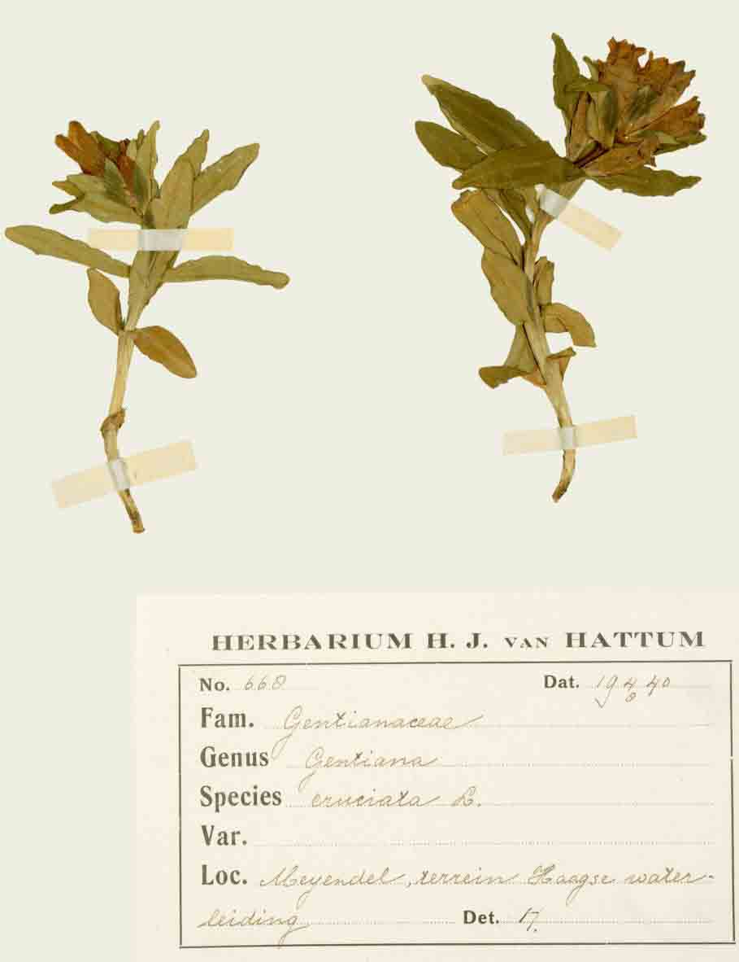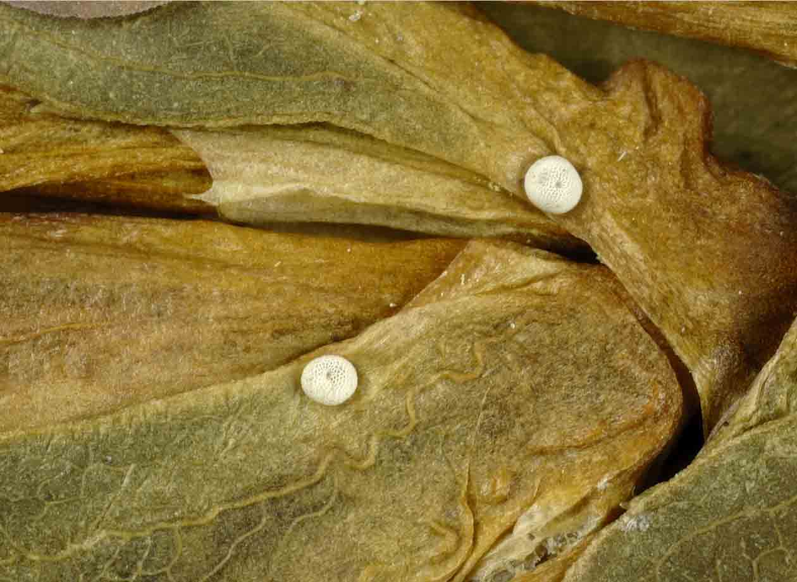
Eggs of unknown subspecies of Maculinea alcon (Gentiaanblauwtje)
on herbarium specimens of Gentiana cruciata (Kruisbladgentiaan)
(photo’s by Ben Kieft)
Methods: DNA isolation, PCR, cloning, DNA sequencing
Required: Molecular Biological Techniques course (HBO/WO level)
Supervision: Dr. Barbara Gravendeel (ancient DNA lab), Dr. Erik van Nieukerken (Naturalis) and Dr. Michiel Wallis de Vries (Vlinderstichting)
Localities: Naturalis (entomology department), v.d. Klauw (general molecular lab) and v. Steenis building (herbarium, ancient DNA lab)
Period: anytime (mininum of 3 months)
Contact: gravendeel@nhn.leidenuniv.nl

References

Als, T.D., R. Vila, N.P. Kandul, D.R. Nash, S.H. Yen, Y.F. Hsu, A.A. Mignault, J.J. Boomsma & N.E. Pierce. 2004. The evolution of alternative parasitic life histories in large blue butterflies. Nature 432: 386-390.

Lempke, B.J. 1942. A new Dutch race of Lycaena alcon F. Natuurhistorisch Maandblad 31: 106-107.

Wynhoff, I. 2006. Gentiaanblauwtje. In: F. Bos, M. Bosveld, D. Groenendijk, C. van Swaay, I. Wynhoff, Vlinderstichting (eds.), De dagvlinders van Nederland, pp. 172-176. KNNV Uitgeverij, Utrecht.

Zeisset, I., T. Damm Als, J. Settele & J.J. Boomsma. 2005. Microsatellite markers for the large blue butterflies Maculinea nausithous and Maculinea alcon (Lepidoptera: Lycaenidae) and their amplification in other Maculinea species. Molecular Ecology Notes 5: 165-168.

